Introduction: 1
Project Management Methodologies: 1
2.1 Waterfall Methodology: 1
2.2 Scrum Methodology: 2
2.3 RAPID APPLICATION DEVELOPMENT: 3
3. Critical evaluations of chosen methodology. 4
4. Māori inclusion in the project. 5
5. References: 5

Introduction:
In this report where three methodologies will be analysed and select one that is more suitable and relevant to this project which is online simulation game for OPAIC veterinary nursing course. In this report project details such as the methodology choose and why it is relevant to this project and the budget of the project is discussed in detail.
During this pandemic situation, learning online became more popular since it is the safest and easiest way to learn. It did change the way of learning. Pretty much everything is learnt virtually and been taught virtually. This report gives the detail of the project which been developed for OPAIC called online simulation game. This will be used by the Undergrads of the veterinary nursing course. This online simulation game is the virtual game where you can interact with using some tools.
In order to ensure project goes in right direction project management methodologies will be induced into the project. Project management methodologies ensures the project organizing, estimating costs and providing tools, accordingly, helps to avoid major risks, cost benefit and developing team skills are some of the benefits (Charvat, 2003). In this project critically analysed and choose three methodologies which are relevant to this project and discussed. Those are, waterfall methodology, scrum methodology and RAD methodology. Out of these three Scum methodologies has been critically analysed and chosen for this project as it is more relevant.

Project Management Methodologies:

2.1 Waterfall Methodology:
This approach was established in 1970 by Winston w. Royce. This methodology has five stages in it. Where it requires previous stage to be completed to move on to the next stage. This methodology is very ideal for the projects like software development (Chari, 2018). This methodology has five stages:
Requirements: During this stage, requirements from the client that required for this project will be gathered and outlined the project in big picture. There are many high-level statements that can be used or implemented in many ways (Chari, 2018). This the stage where the planning of the project will start. For example, OPAIC online simulation game project requirements such as including how to care for range of domestic and farm animals, security like logins for the site, a chat utility and a data base to store the previous data are to be gathered and outlined.
Design: Once you gather all the requirements and understand them, the next step is to come up with the design. This design again needs to meet the client requirements (Chari, 2018). For example, this game simulation requires such a User Interface that is suitable to use for undergrad students at ease. Also designing the database that let them store the stuff they need.
Implementation: At this stage, you start implementing the requirements that are gathered for designing the online simulation game for OPAIC. This involves collecting data to check if the requirements are suitable to implement.
Verification: During this phase, you take the implemented requirements which are designed to test whether it works according to OPAIC. This testing stage is to validate the designed product with the requirements (Eason, 2016). For example, this stage is to test the site and use to see if the OPAIC online simulation game is made accordingly as per requirements are not.
Maintenance: At this final stage, the implemented system needs to be maintained (Eason, 2016). This involves upgrading the systems that are required for the OPAIC project on the go and software updates that are needed in daily function.
The reason this methodology is considered for this project is, this methodology has clear end goal and fixed timeline. There also won’t be any frequent collaboration or team meetings. There also won’t be any frequent feedbacks apart from established milestones. Which makes easier for the project managers to plan and communicate with stakeholder of OPAIC regarding the project and that helps in the project success.
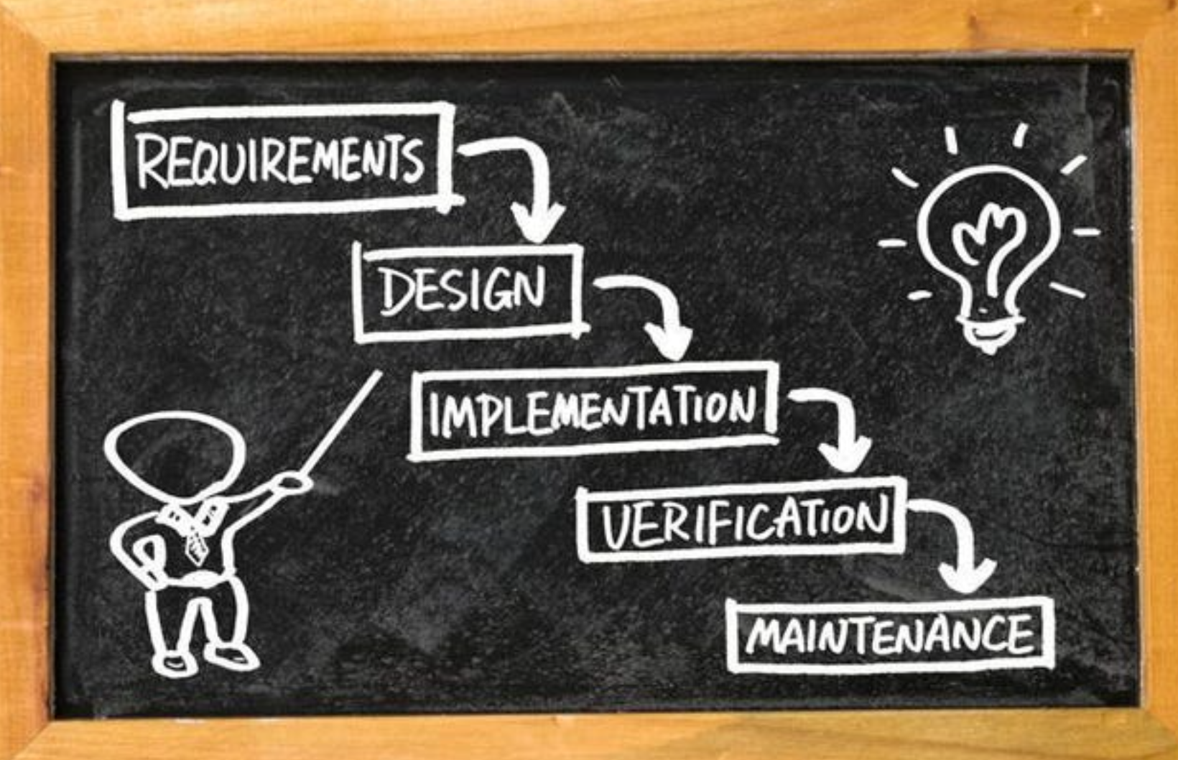
Figure: 1 (Eason, 2016)

2.2 Scrum Methodology:
In the scrum methodology, every document or detailed description in not provided on how the project must be done. Most of the things were left to the software development team itself. Because they will get to know how to solve the problems on their own (Schwaber, 1997).
Therefore, in the scum development, there been used sprint planning meeting described in terms of desired outcome. This also the commitment of the set of variables that is to be developed in the next sprint instead of Entry criteria, Task definitions, validation and Exit (Schwaber, 1997).
Scum mostly relies on the self-organizing and cross functional team although there is scrum master. This means there won’t be any team leader to ask you to do those specific tasks. Instead, you must work on your own (Schwaber, 1997). For Example, in the game simulation project of OPAIC project, there will only team member who work on it and the work will be distributed by scrum master accordingly. Even the issue also needs to be resolved within the OPAIC team. In this case OPAIC will play the product owner role.
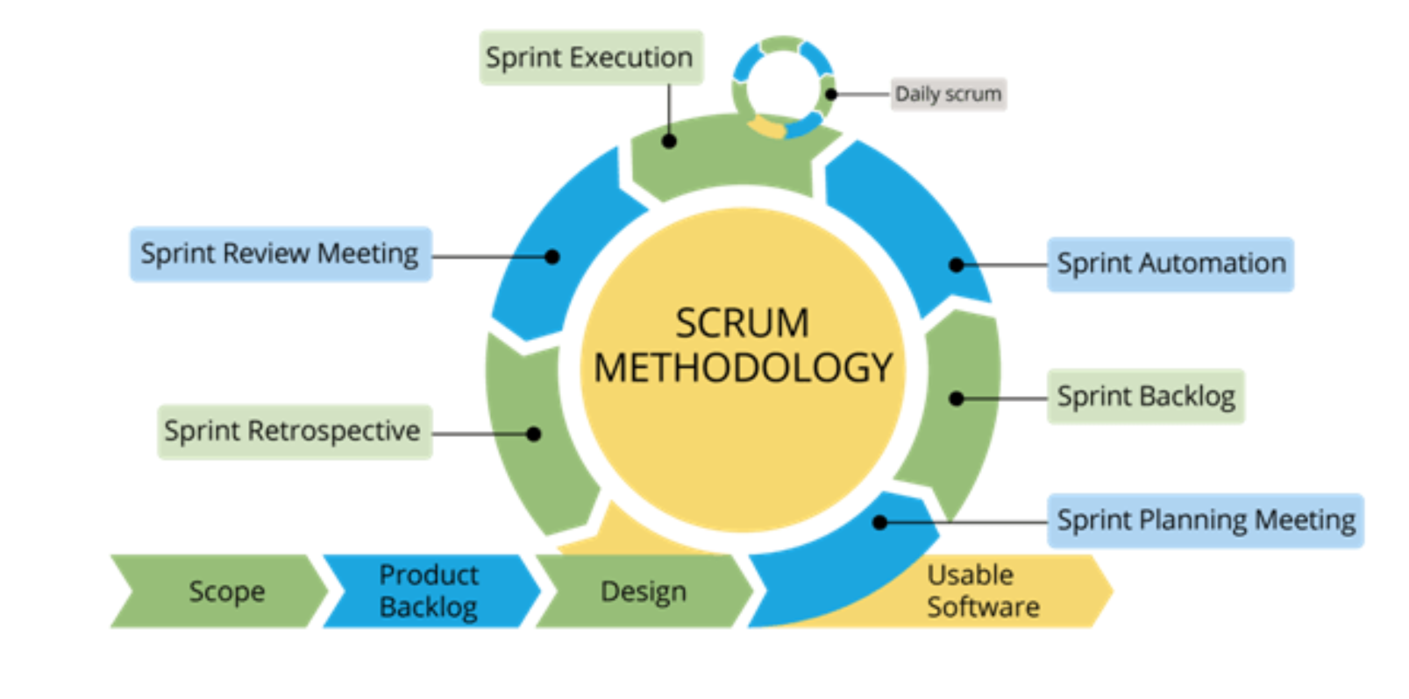
Figure: 2 (Schwaber, 1997)
Scrum project will process through the series of the sprints. To stick to the methodology these sprints are the timeboxes which lasts no more than a month but most commonly two weeks. For example, the development of game simulation project will be breaking down into pieces which in turn called sprints. These involves requirements, designing, development and testing the game simulation project (Sharma,2016).
Scrum methodology has very important which involves the scum meetings. These meeting are held everyday in the start to discuss the updates, work done so far and what needs to be done next (Sharma, 2016). Since this OPAIC project is related to the game simulation of the how to care animals to diagnose the correct treatment, the daily meetings need to be held for latest updates.
In scum methodology, it is easy to rectify and remove mistakes. It is very transparent and visible of all stages throughout the project. It has small sprint times boxes which makes them to make changes easily throughout the project (Sharma, 2016). These are the reasons which made to consider this methodology for game simulation project to be successful.

2.3 Rapid Application Development:
RAD is the agile methodology which is very popular in software development. It was first introduced in 1991 by James Martin. Rad approach is very fast to turnaround, this is one of the attractive methodologies for developers. This fast pace made Rad to focus on minimising the planning stage and maximizing the product prototype development. This made the project managers and stakeholders to track the project and measure the project accurately. RAD also helps the projects to communicate in real time to solving issues. This made RAD very popular methodology among the software development (Huisman, 2003).
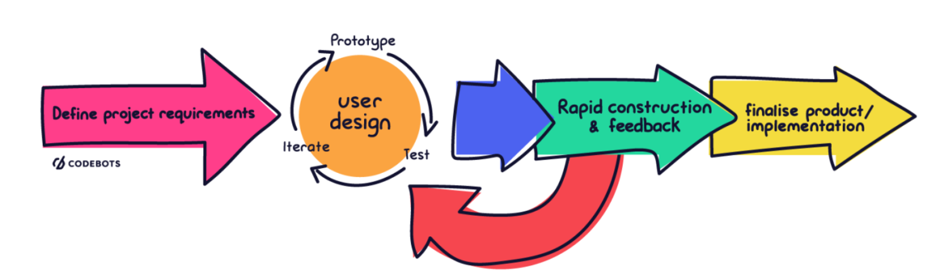
Figure: 3 (Huisman, 2003).
RAD has four stages, firstly Requirements planning stage, during this stage developers, clients and team members communicate to make the end goals for the project and issues related to the project (Huisman, 2003). In this stage OPAIC will be conducting meeting with all the team members and the developers to gather the requirements and research the issues related to it. And at the end of this stage requirement will analysed and finalize.
Secondly, User design, in this stage once the project is scoped out you will be jumped on to the development and building the User design (Huisman, 2003). In this stage, project who is working on the game simulation project will start building the game simulation project. They will also ensure the design is meeting the requirements.
Thirdly, Rapid construction. In this stage, the prototype developed from the last stage will be taken to next level by converting it in to working model (Beynon-Davies, 1998). This involves preparation for construction, programming, and testing. In the game simulation project developed of OPAIC, the team of programmers, coders, testes, developers work together during this stage to get the end product as per the requirements.
Fourthly and last stage, Cutover. In this state the final product after different types of testing goes in to live (Beynon-Davies, 1998). In this stage, training on the end product of the game simulation project like how to use is also important, this is called user training.
Advantages of this methodology which made us to consider for this project are, RAD lest you to make them into small pieces of the project which makes us easy to manage, also since RAD allow the project manager to optimize the project which in turn allows the team to perform efficiently. Regula feed backs and constant communication are also the reasons which make the OPAIC project successful.

3. Critical evaluations of chosen methodology:
After critically evaluating, for the OPAIC project, scrum methodology has been recommended for this project over the traditional methodology. Because, firstly, scrum methodology is very flexible over other two methodologies mentioned above (Sharma, 2016). It allows the developers to make changers at any time of the project. Not only the developers but also tester can test the bugs or issues and resolve them simultaneously (Schwaber, 1997).
Secondly, Scrum helps teams to complete the OPAIC project fast and can deliver quickly due to its sprints. These sprints are the tiny pieces of time boxes which are been put together once they are developed by the team. Team can work individually on these sprints which make the team to work more efficiently (Schwaber, 1997).
Thirdly, scrum also has the effective time and money management, which allows the OPAIC project more cost effective in making this project. Scum methodology very transparent, one can go check the work at any stage of the work, thanks to its sprints (Sharma, 2016).
Being an agile methodology, this methodology adopts the feedbacks from customers and stakeholders (Sharma, 2016). And again, the short sprint helps the OPAIC project make changes based on the feedback at any stage of the project.
And lastly scrum meeting, since this is online simulation game related to the veterinary students there will a lot of updates must be flooding in to make changes accordingly in day-to-day basis. This is where these meetings play a crucial role in the project since they been conducted every day at the beginning, all the updates, changes and blockers were discussed in-depth. All the doubts will clear at this point and team can focus on work for the rest of the day. These scrum meeting allows to work more effectively and can track the work more easily. This supports the project to run smoothly and successful.

4. Māori inclusion in the project:
For the OPAIC project three Māori values has been chosen which are very relevant. It is recommended to include in this project for the project success. Those three Māori values are,
Kotahitanga: This Māori value ensure the unity in the team. Enforcing this value into the project make the project easier to achieve the goal since it ensures the unity in the team which leads to the success of the project (Bishop, 2009). This Māori value also ensure supporting each other. Project like this, needs more support from each other since this can be achieved with the teamwork this Māori value more important to practice.
Maramatanga: This Māori value ensure the team is following the proper rules accordingly. For the success of the project, it not only important to work efficiently but also need to work according to the rules is also important. This value also ensures the team is learning something at tall the stages (Smith, 2004). Since this the software development learning at all stares and learning new thing that are relevant to the project is very import for the project success.
Tikanga: This mauri value is about the leadership. Every project needs a leader to drive you in the right direction for success of the project (Harmsworth, 2006). Practicing this Māori values in this project will ensure the project runs smoothly and accordingly.

5. References:
Charvat, J. (2003). Project management methodologies: selecting, implementing, and supporting methodologies and processes for projects.
Chari, K. (2018). Impact of incorrect and new requirements on waterfall software project outcomes. Empirical Software Engineering, 23(1), 165-185.
Eason, O. K. (2016). Information systems development methodologies transitions: an analysis of waterfall to agile methodology.
Schwaber, K. (1997). Scrum development process. In Business object design and implementation (pp. 117-134). Springer, London.
Sharma, S. (2016, April). A comprehensive study on state of Scrum development. In 2016 International Conference on Computing, Communication and Automation (ICCCA) (pp. 867-872). IEEE.
Huisman, M. (2003). Systems development methodology use in South Africa. AMCIS 2003 Proceedings, 129.
Beynon-Davies, P. (1998). Integrating rapid application development and participatory design. IEE Proceedings-Software, 145(4), 105-112.
Bishop, R. (2009). Te kotahitanga: Addressing educational disparities facing Māori students in New Zealand. Teaching and teacher education, 25(5), 734-742.
Smith, G. H. (2004). Mai i te maramatanga, ki te putanga mai o te tahuritanga: From conscientization to transformation. Educational Perspectives, 37(1), 46-52.
Harmsworth, G. R. (2005). Report on incorporation of traditional values/tikanga into contemporary Maori business organisations and process. Landcare Research, prepared for Mana Taiao.

